Assembled Partition as Combo Layout

In our example, we will estimate 1000 assembled sets created with a length partition with 3 slots combined with a width partition with 2 slots, therefore the quantity per set will be 2 and 3 respectively to produce each finished assembled partition set. As you can see our image that will import to the box design folder will show the assembled set. This image can be displayed on the plant floor for the plant employees to confirm how the final item will look.

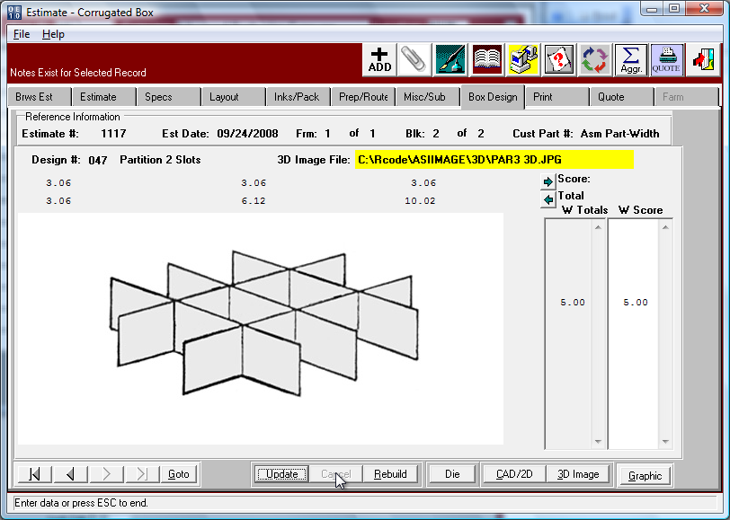

Assembled Partitions – Machine File Standards

The assemble machine should be defined as a unique department such as HL for Hand Labor or AP for Assemble Partition. Department code may be added under the menu keys N-Z-4. The machine feed type is critical for proper run time calculations. Press the F3 key on this field and read the help text. ASI recommends feed as "P" for Partition Assembly, as this machine will calculate run hours based on the total quantity of all partition blanks. If the Partition Assembly machine ran at 1000 parts per hour and we need 1000 final assembled sets then this would assemble a total of 3000 width partitions and 2000 length partitions. Therefore 5,000 parts divided by the machine run speed of 1000 equals 5 hours. When the feed is "A" for Assembly, this machine will calculate run hours based on the quantity of sets per hour regardless of how many sheets or blanks are defined on that form (sheet), which will only yield 1 machine hour. The flaw in this method is that a partition made with a combination of two 1 slot partitions will run as fast as an assembled partition with 3 slots combined with a 2 slot partition, which is not reality.

Both feed types of P or A will use the machine limits of Length, Width and Caliper as limits against the assemble sets dimensions length, width and depth respectively. The time required to cut each partition prior to the assemble machine will be your normal box machinery that cuts the partitions such as slotters, slitters, die cutters and other machines.

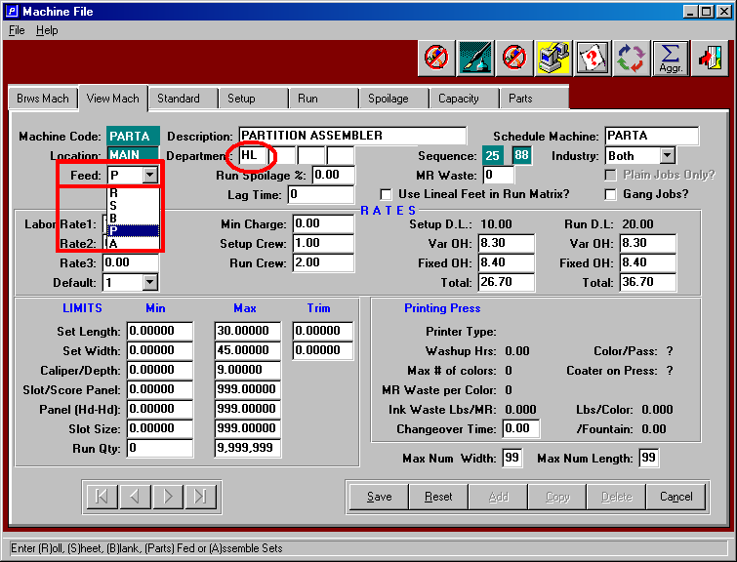

Assembled Partition as Combo Layout

Assembled Partitions are estimates with a length partition and a width partition. When adding a new estimate you must click Assembled Partition Button. The program will then prompt for the length, width, depth, board material, number of slots and cell dimensions.

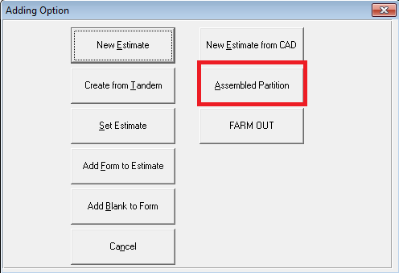

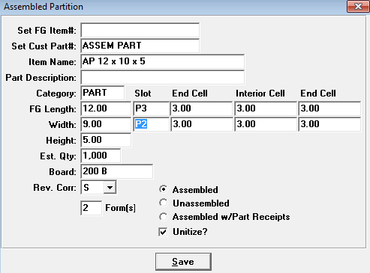

Assembled Partition as Combo Layout

The program will compare the limits of the machine that will assembly the partition to confirm that the partitions length, width and caliper thickness will fit the machine limits. If the partition limits are too small or too large, the partition assembly machine will not transfer to the machine routing.

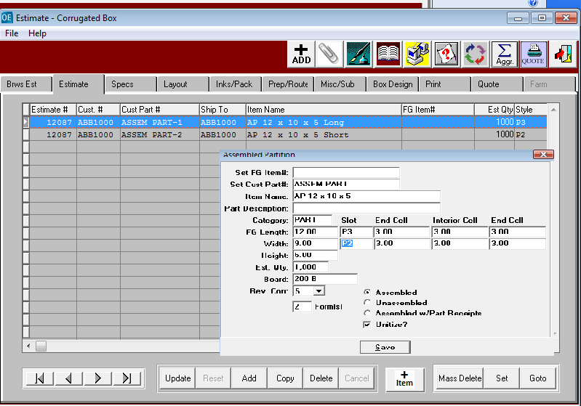

Assembled Partition as Combo Layout

Adding each part is simply adding each part as if the item were a separate estimate.
After adding the first partition, you will click the ADD button again and then select either Add for Form to Estimate if each partition is cut out of a unique sheet of board. If the partitions are combined on one sheet of board and cut together, then select the Add Blank to Form as this becomes a combination sheet layout. Please note, in this example both partitions will be cut from the same sheet. Equally important is the quantity per set which indicates how many parts of each item. Since we are estimating 1000 sets, we will need 2000 lengths and 3000 widths.

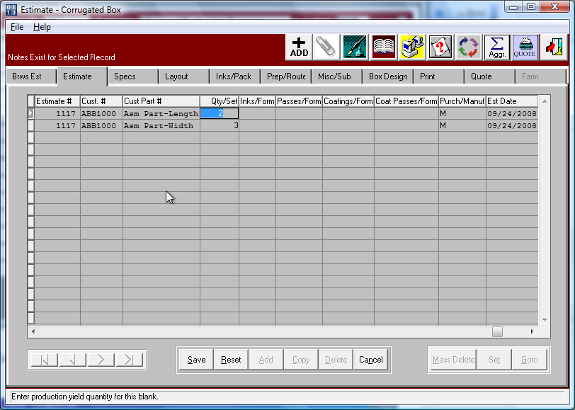

Assembled Partition as Combo Layout

The GOTO button on the ESTIMTE folder allows the definition of the blanks on the sheets.
Each partition is cut from the same sheet, hence there be just one layout page with the die dimensions. In this example, I have die cut sheet known as form 1 as a 25 up die cut with the length partition as a 5 x 2 and the width partition as a 5 x 2 layout. The total number up will calculate the sheet size that will be used to determine the run time on the machine.

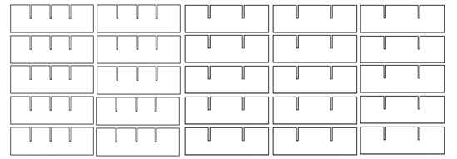

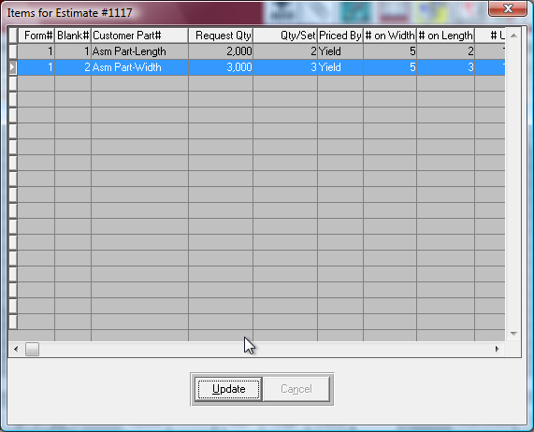

Assembled Partition as Combo Layout – Layout Folder

The LAYOUT folder AUTO CALC button is used to automatically calculate the die size and sheet size based on the layout defined on the estimate folders GOTO buttons layout for both the length and width partitions. The system calculates the die size width by multiplying the number up on the width time the blanks largest width. The die size length is calculated by add both the length and width partitions blank length time the number of each. Therefore, the partition length is 2 up times length of 12 inches equals 24 inches is then added to the width partitions blank length of 10 inches times 3 up for a total of 54 inches for the sheet length.

However, since I have defined a 56 machine that will die cut the partitions, the machines trim allowance imports to determine the total sheet size.

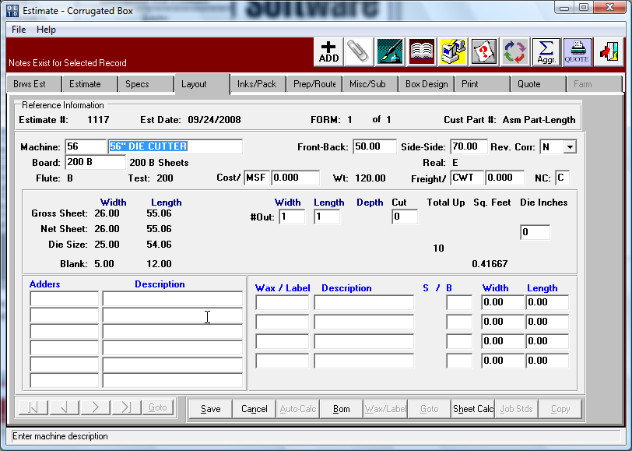

Assembled Partition as Combo Layout – Layout Folder

The LAYOUT folder has a SHT CALC button that allows selecting a stocked sheet in seconds by showing the available sheets with the least waste at the top of the display. In this example, I will trim the sheet on the slitter machine before running the sheet through the die cutter. As you can see, the system displays all the sheets sorted by sheet with the least amount of waste. The estimator has the option to select only sheets on hand or only sheets not committed or all stocked sheets regardless of quantity. The estimator simply high lights the board with the preferred number out on the slitter then the program will transfer to the layout folder.

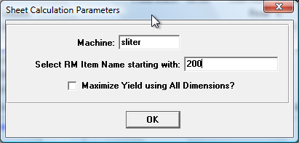

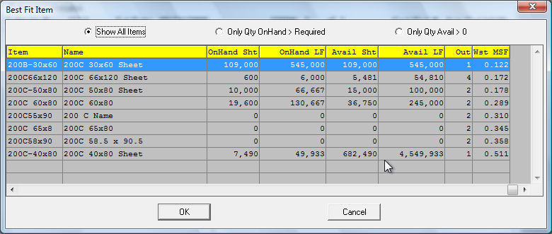

Assembled Partition as Combo Layout – Layout Folder

Once the estimator selects the stocked sheet for the job, the LAYOUT folder will display the final die size and sheet die. This sheet size will be used to calculate the total cost of board material.
The sheet size and number out will also be used to calculate the number setup and run hours for the die cutter and slitter or slot machines. The total estimated quantity required of 1000 assembled sets is multiplied by the quantity per set of 2 for the length partition which yields a total blank quantity of 2000 length partitions. Since the length is 15x2 or 10 up the sheet this will require sheets just 200 sheets if we assume zero waste. Of course, each machine will have a standard defined for setup waste as well as running spoilage that will increase the total sheets required.

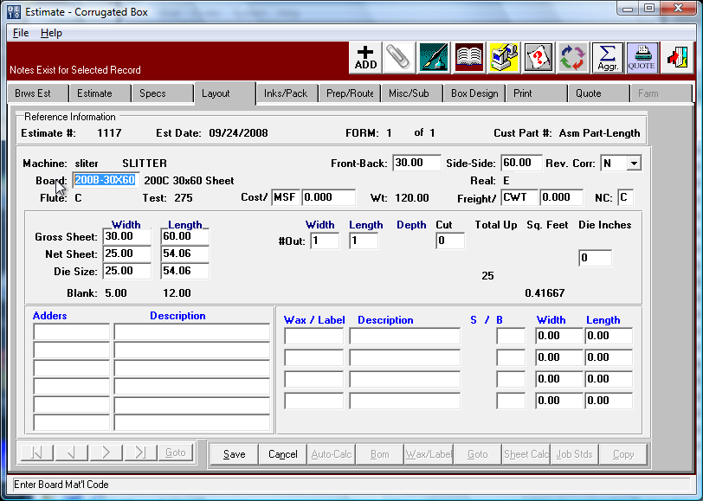

Assembled Partition as Combo Layout – Length Partition

The SPEC folder is automatically built from the ESTIMATE folder once the estimator enters the partition style, size, board material and quantity per set. However, the SPEC folder provides the ability to make changes or to assign a die image, die number, cad image, cad number, plate number and to modify the sales representative or the commission percentage.

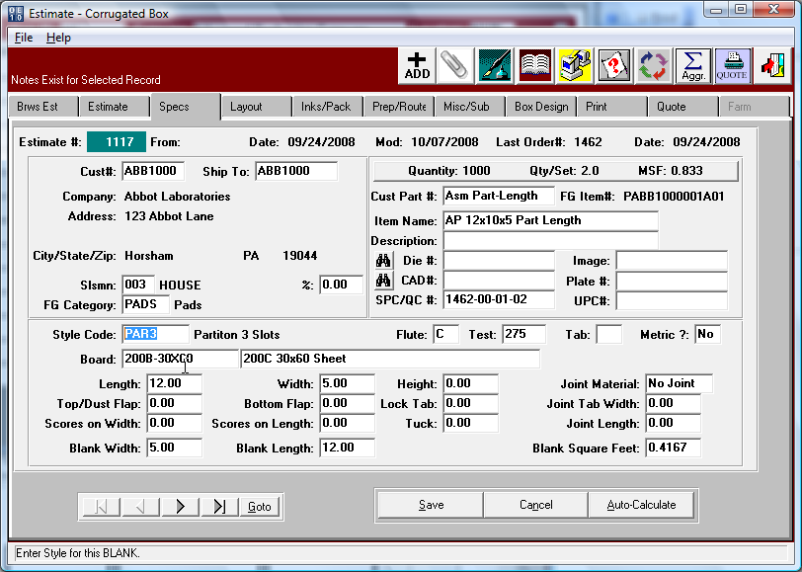

Assembled Partition as Combo Layout – Length Partition

The BOX DESIGN folder automatically imports the picture image of the partition that the factory must manufacturer complete with each panel size, once the size and panels are added to the ESTIMATE folder or modified on the SPEC folder. This shows the length partition that will be produced. The UPDATE button allows changing the panel sizes.

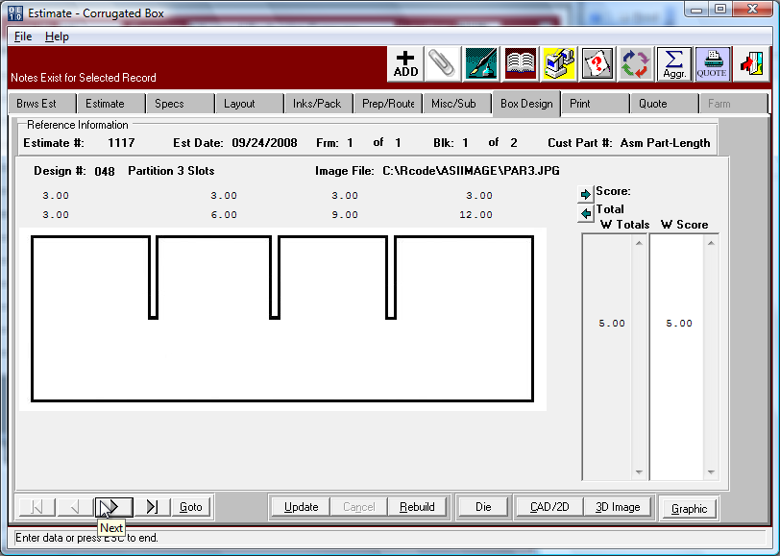

Assembled Partition as Combo Layout – Width Partition

The SPEC folder is automatically built from the ESTIMATE folder once the estimator enters the partition style, size, board material and quantity per set. However, the SPEC folder provides the ability to make changes or to assign a die image, die number, cad image, cad number, plate number and to modify the sales representative or the commission percentage.

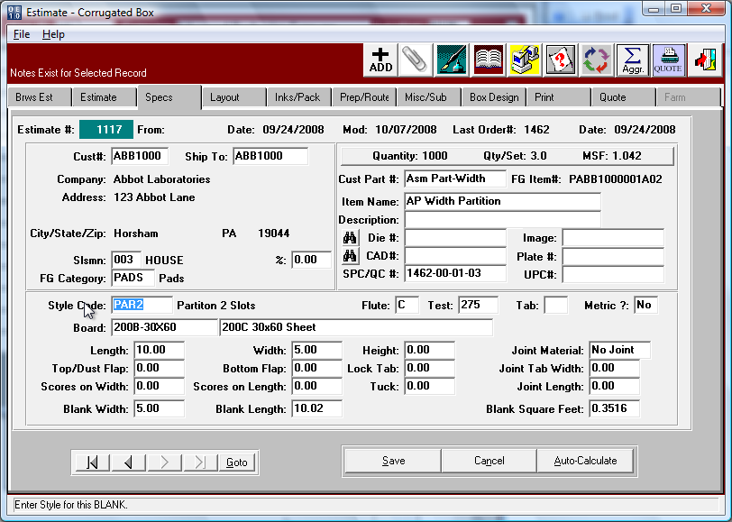

Assembled Partition as Combo Layout – Width Partition

The BOX DESIGN folder automatically imports the picture image of the partition that the factory must manufacturer complete with each panel size, once the size and panels are added to the ESTIMATE folder or modified on the SPEC folder. This shows the width partition that will be produced. The UPDATE button allows changing the panel sizes.

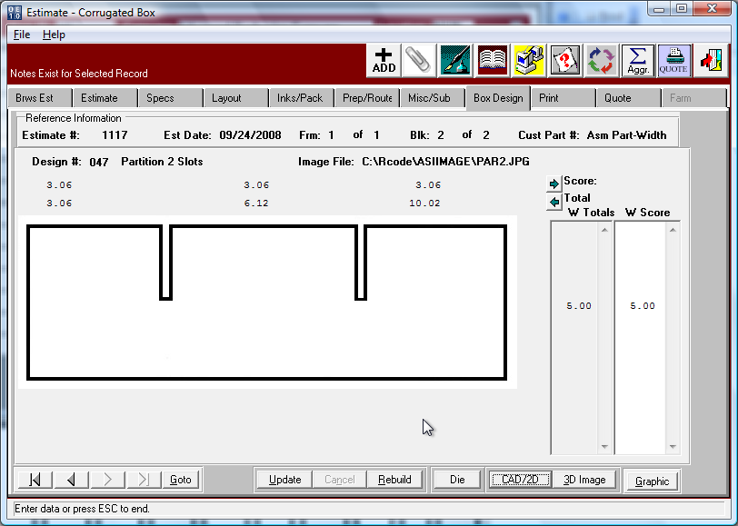

Assembled Partition as Combo Layout

Entering the freight and packing for an assembled set is defined on form 0, which can be accessed by pressing the back arrow keys. This any set or partition were shipped unassembled, this screen would not be available. Packing for each partition is defined as normal and can define how to unitize each partition on a pallet for delivery to the partition assembly machine.
Please note, the freight costs will only use Form 0 for assembled sets.

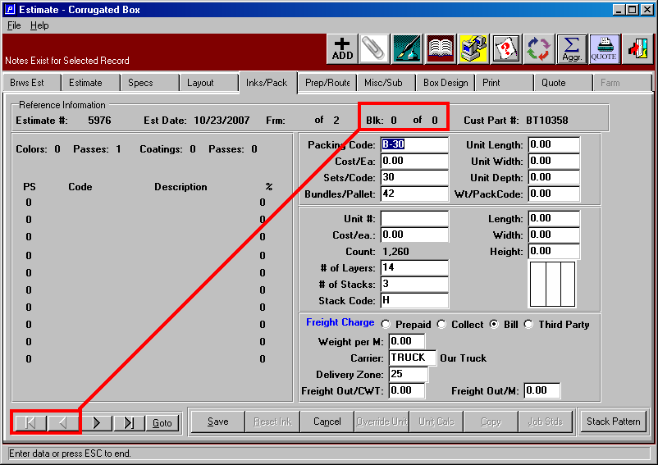

Assembled Partition as Combo Layout

The machine routing will import machines based on each style’s routing matrix defined.
Therefore, form 1 will have a machine routing that could be different from form 2.
The partition assembly should be on the last form and will calculate based on the feed type.

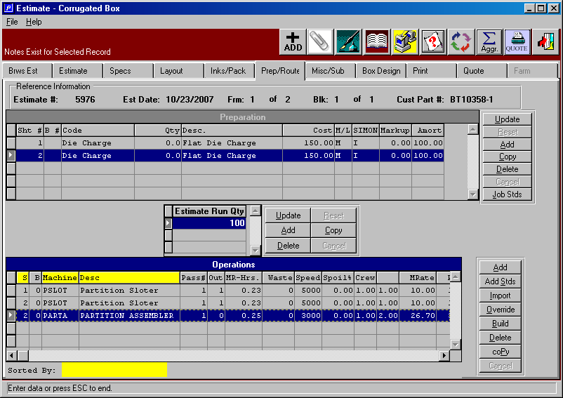

Assembled Partition as Combo Layout

The PRINT FOLDER will calculate the cost of the assembly set by pressing the CALCULATE button. The VIEW button will display the cost of each line item. The HARDCOPY button will print the estimated costs. The QUOTE button will create a quote that can be emailed to the customer.

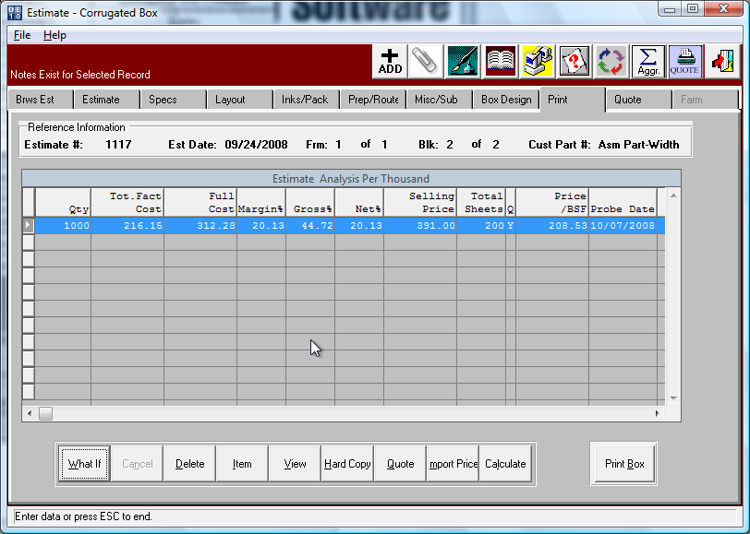

Assembled Partition as Combo Layout

The Item button on the PRINT folder will display the cost of each part, whereas the print folder displays the cost and sell price of the entire assembled set.

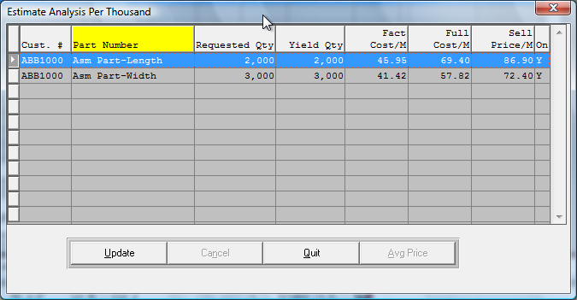

Assembled Partition as Combo Layout

The Item button on the PRINT folder will display the cost of each part, whereas the print folder displays the cost and sell price of the entire assembled set. The estimate will print each partition with costs showing the cost of each component if estimated separately. However, the summary, will roll the costs of each part into the set and display the costs of the assembled partition as a set.

